**Database design of the**

**application store**

**Submitted by Under the guidance of**

Sami Ranjan Shekhar Prof. Vincent Lattuada

CONTENTS

|  |  |
| --- | --- |
|  |  |
| **Title** | **Page No** |
| Introduction | **3** |
| Cluster:Application | **3** |
|  |  |
|  |  |
|  |  |
|  |  |
| Cluster: DEVELOPER | **6** |
|  |  |
|  |  |
|  |  |
| CLUSTER: USERS | **7** |
|  |  |
| Cluster: PAYMENTS | **10** |
|  |  |
|  |  |
|  |  |
| CLUSTER: DOWNLOADS  HIGH LEVEL CLUSTER DIAGRAM | **11**  **12** |
|  |  |
| DDL Script | **13** |
| Querries | **21** |

**Database Design of an Application Store**

The Application Store is an online portal that is provided by the phone OS company(Android store/Apple store) through which applications can be downloaded by the users on their devices (mobile phones, tablets) based on different factors such as support, compatibility etc.

The application store can be divided into several major clusters. The clusters considered for this app store are applications, downloads, users, developer and payment.

Application Store Major Entities

*Cluster: Applications*

The application cluster would consist of 4 tables: Applications, Category, Version, Ratings and reviews.

**Application**

* The Application table consists all the primary details of the application. It holds the names of the applications, application id along with a short description.
* The category of the application and the version of the app. It could have some screenshots of the user interface of the application, to have an overview of what the app would look like. There would be a column with the developer name/Company name.
* One to many relationships between application and the developer can be made.

Business Rules:

* An application has to have a developer associated with it, though it can also have multiple developers associated.
* The application has to be within one category.

|  |  |  |  |  |
| --- | --- | --- | --- | --- |
| **Name** | **Data Type** | **Define** | **Example** | **Null/key** |
| AppID | VarChar(10) | A numeric ID assigned to the application | 45444 | NN/PK |
| DeveloperID | VarChar(10) | A numeric ID assigned to the developer | 54567 | NN/FK |
| AppName | VarChar(20) | Name of the application | Ashphalt 8 | NN |
| AvgUserRating | Float | Avg Rating of the application(It should be between 1 and 5) | 4.4 | NN |
| CategoryID | VarChar(10) | Category of the application | 111 | NN/FK |
| DateCreated | Date | Date the app was created | 05/08/2016 | NN |
| DateLastUpdated | Date | Date the app was last updated | 08/08/2016 | NN |
| AppDesc | Varchar(250) | A short app description | A thrilling shooting game. | NN |
| Compatiility | Varchar | This defines the OS version and above that supports the app | IOS 10 and above | NN |
| AppSize | VarChar | Size of the app | 65 MB | NN |
| AgeRating | SmallInt | Age group the app is intened to be used by | 17 | NN |
| DownCount | INT | No of downloads | 54433 | NN |

**Category**

* This table will contain the type/genre of the application and will help to fetch all the applications in the same category with ease.
* The Category and Application will have a one to many relationship as one category can have multiple applications.

Business Rules:

* Every application must have at least one category associated with it.
* Every Category must have at least one application associated with it.
* Only the author of an application can define the category it is associated with.

|  |  |  |  |  |
| --- | --- | --- | --- | --- |
| **Name** | **Data Type** | **Define** | **Example** | **Null/Key** |
| CategoryID | VarChar(10) | A unique category ID assigned to every category | 111 | NN/PK |
| CategoryName | VarChar(20) | Category of the application | Gaming | NN |
| CategoryDesc | VarChar(50) | NN/FK | Immerse in the gaming |  |

**Version**

* The version of the downloaded application
* Can be connected to the users and the application table to show the version of the app that the user has downloaded

Business Rules

* A version of the app should be unique when connected to the user
* Version can only be released by the Author of the application.
* Two different versions of an application can exist on two different devices associated with a single user.

|  |  |  |  |  |
| --- | --- | --- | --- | --- |
| **Name** | **Data Type** | **Define** | **Example** | **Null/Key** |
| VersionID | Varchar(10) | A numeric ID given to the version | 4243 | NN/PK |
| VersionName | VarChar(10) | The version Number | 1.1 | NN |
| ReleaseDate | Date | The date of the release of the version | 09/08/2015 | NN |
| AppID | VarChar(10) | Application ID of the application the version is associated with | 45445 | NN/FK |

**Ratings and Reviews**

* It can also contain a review column for the app reviews provided by the users.
* Also it will be linked to the application table through the application ID.

Business Rules:

* One user can provide only one rating for an application.
* A rating ID which will contain the rating and it will be linked to the user table through UserID and Application table through AppID
* This table can contain a rating column for each application where a constraint can be added so as to accept only integer values from 1 to 5.
* Only the users who have downloaded the application can give a rating

|  |  |  |  |  |
| --- | --- | --- | --- | --- |
| **Name** | **Data Type** | **Define** | **Example** | **Null/Key** |
| Rating ID | VarChar(10) | Assigned to rating with a unique number | 46 | NN/PK |
| UserID | VarChar(10) | User detail about the user who provided the rating | 67777 | NN/FK |
| AppID | VarChar(10) | Application for which the rating was given by the user | 45444 | NN/FK |
| Reviews | Varchar(300) | Review by the user | Great game |  |
| DateCreated | Date | Date on which the rating was given by the user | 08/06/2017 | NN |
| UserRating | Float | Rating given by the user(1 to 5) | 4 |  |

*Cluster: Developer*

**Developer**

* It will contain the application’s developer details. It can contain fields like Developer name, developer ID and similar applications that have been designed by the same developer.
* As stated earlier it would be linked to the application table.

Business Rules:

* A developer can have multiple apps to his name but it can’t have 0 apps to this name.

|  |  |  |  |  |  |
| --- | --- | --- | --- | --- | --- |
| **Name** | **Data Type** | **Define** | **Example** | | **Null/Key** |
| DeveloperID | VarChar(10) | An ID that is assigned to the developer. | 756 | | NN/PK |
| DeveloperName | VarChar(20) | Name of the developer on the app store | Gameloft | | NN |
| AppCount | INT | Number of apps developed by the developer | 34 | |  |
| DevBankID | VarChar(10) | ID to Identify the Bank details of the developer | 675767 | NN/FK | |

**Developer Bank Details**

* Stores the bank details of the developer and has restricted access.

|  |  |  |  |  |
| --- | --- | --- | --- | --- |
| **Name** | **Data Type** | **Define** | **Example** | **Null/Key** |
| DevBankID | VarChar(10) | ID to Identify the Bank details of the developer | 675767 | NN/PK |
| DevAddress | Varchar(100) | Address of the Developer | 114 Boylston street, Boston | NN |
| DevRoutingNo | INT | Bank routing No of the developer | 45365555 | NN |
| DeveloperAccNo | INT | Acc No of the developer | 876865453 | NN |

*Cluster: Users*

**Users**

* User table will contain user details and also it will have the data for all the apps that the user has downloaded.
* It will have columns like Username, User ID as well as all the invoices that are associated with the user and the apps purchased/downloaded.
* User ID can be associated with the invoice ID in the invoices tale.

Business Rules:

* The password has to be protected by the app store regulators and can’t be shared
* Users must have an account with a UserID to download an application.
* User must provide email and payment details to create an account.

|  |  |  |  |  |
| --- | --- | --- | --- | --- |
| **Name** | **Data Type** | **Define** | **Example** | **Null/Key** |
| UserID | VarChar(10) | A unique identifier for the user | 101 | NN/PK |
| Fname | VarChar(20) | The first name of the user | Sami | NN |
| Lname | VarChar(20) | The last name of the user | Ranjan | NN |
| EmailID | VarChar(20) | Email ID of the user | Ranjansami@yahoo.com | NN |
| Contact | Char | Contact Number of the user | 8882229274 | NN |
| Address | VarChar(50) | This will contain the address of the user | 60 saint germain Street, Boston MA- 02115 | NN |
| Password | VarChar(20) | This is contain the password that will help the user to login and will only be accessed by the appstore | Possible123 | NN |

**User Bank Details**

* Consists of the bank details of the users, including Account Number, Routing number, card no and expiry date.

|  |  |  |  |  |
| --- | --- | --- | --- | --- |
| **Name** | **Data Type** | **Define** | **Example** | **Null/Key** |
| UserBankName | VarChar(20) | The name of the user banks name | Bank of America | NN |
| UserAccountNo | INT | The users account number | 5546336676 | NN |
| UserBankRoutingno | INT | The routing number of the bank | 244421 | NN |
| UserCardNo | INT | The card number of the user | 4335543356675543 | NN |
| CardExpDate | Date | Card Expiry Date | 01/02 | NN |

**Device**

* The device associated with the app store
* It can be joined with the user ID so as to keep a track of the users downloads

Business Rules:

* The device ID should be unique
* It will specify the apps on that unique device
* Any Application can be downloaded to a device only if its compatibility matches with the device.

|  |  |  |  |  |
| --- | --- | --- | --- | --- |
| Name | Data Type | Define | Example | Null/Key |
| DeviceID | VarChar(10) | A numeric ID given to the Device | 3533 | NN/PK |
| UserID | VarChar(10) | The user ID associated with the device | 4353 | NN/FK |
| DeviceName | VarChar(20) | Name of the device | Sami’s Iphone | NN |
| Devicetype | VarChar(20) | Model of the device | Iphone x | NN |

*Cluster: Payment*

**Invoices**

* This table will contain the purchase details associated to each user ID. The purpose of the table is to hold the transaction details of the purchases made on the app store.
* This table can include columns like Invoice ID, App ID (linked to the application table), Date of payment etc.

Business Rules:

* This will connect the userID who have purchased the apps with the appID.
* Mode of payment can only be credit card or debit card.

|  |  |  |  |  |
| --- | --- | --- | --- | --- |
| **Name** | **Data Type** | **Define** | **Example** | **Null/Key** |
| InvoiceID | VarChar(10) | Transaction ID is a unique identifier for the transaction | 576487 | NN/PK |
| UserID | VarChar(10) | This will link the user/Developer tables to application table | 101 | NN/FK |
| PaymentType | VarChar(10) | Made by user or the developer.  Furthur the details can be taken out from the User or the developer table. | user | NN |
| PaymentDate | Date | Date of payment when the app was purchased | 09/08/2017 | NN |
| PaymentAmount | Money | The payment amount for the application | $4 | NN |
| PaymentMode | VarChar(1) | Will contain 2 values either C or D for a credit or a debit card | C | NN |

*Cluster: Downloads*

**Downloads**

* This table will contain the number of downloads according to the application ID.
* It will also specify the version downloaded.
* This will also specify the device to which the app has been downloaded through the device ID and the user through user ID

**Business Rules:**

* The downloads table will be linked to the user and the devices table to specify the device on which it was downloaded and the user.
* There can be different entries for the same app when different versions are downloaded to find out which users updated it and who did not.
* Any device or user can download an application multiple number of times.
* An updated version can be downloaded once its available.

|  |  |  |  |  |
| --- | --- | --- | --- | --- |
| **Name** | **Data Type** | **Define** | **Example** | **Null/Key** |
| DownloadID | VarChar(10) | Unique ID defining the download instnace | 5658 | NN/PK |
| AppID | VarChar(10) | App that was downloaded | Ashphat 8 | NN/FK |
| UserID | VarChar(10) | User who downloaded the application | 101 | NN/FK |
| DownloadDate | Date | Date of the download | 05/08/2016 | NN |
| VersionName | VarChar(10) | Version of the application downloaded | 1.1 | NN |

**High level cluster diagram**

The DDL script Generated by the TOAD Data Modeler:

/*

Created: 4/5/2018

Modified: 4/20/2018

Project: Application Store

Model: Microsoft SQL Server 2016

Author: Sami Ranjan Shekhar

Version: 3

Database: MS SQL Server 2016

*/

-- Create tables section -------------------------------------------------

-- Table Application

CREATE TABLE [Application]

(

[AppID] Varchar(10) NOT NULL,

[DeveloperID] Varchar(10) NOT NULL,

[AppName] Varchar(20) NOT NULL,

[CategoryID] Varchar(10) NOT NULL,

[AvgUserRating] Float NOT NULL,

[Downcount] Int NULL,

[AppDesc] Varchar(255) NOT NULL,

[DateCreated] Date NOT NULL,

[DateLastUpdated] Date NOT NULL,

[AppSize] Varchar(10) NOT NULL,

[AgeRating] Smallint NOT NULL,

[Compatibility] Varchar(50) NOT NULL

)

go

-- Add keys for table Application

ALTER TABLE [Application] ADD CONSTRAINT [Key1] PRIMARY KEY ([AppID])

go

ALTER TABLE [Application] ADD CONSTRAINT [AppName] UNIQUE CLUSTERED ([AppName])

go

ALTER TABLE [Application] ADD CONSTRAINT [AppID] UNIQUE CLUSTERED ([AppID])

go

ALTER TABLE [Application] ADD CONSTRAINT [CategoryID] UNIQUE CLUSTERED ([CategoryID])

go

ALTER TABLE [Application] ADD CONSTRAINT [DeveloperID] UNIQUE CLUSTERED ([DeveloperID])

go

-- Table Category

CREATE TABLE [Category]

(

[CategoryID] Varchar(10) NOT NULL,

[CategoryName] Varchar(20) NOT NULL,

[CategoryDesc] Varchar(50) NOT NULL

)

go

-- Add keys for table Category

ALTER TABLE [Category] ADD CONSTRAINT [Key2] PRIMARY KEY ([CategoryID])

go

ALTER TABLE [Category] ADD CONSTRAINT [CategoryID] UNIQUE CLUSTERED ([CategoryID])

go

ALTER TABLE [Category] ADD CONSTRAINT [CategoryName] UNIQUE CLUSTERED ([CategoryName])

go

-- Table Developer

CREATE TABLE [Developer]

(

[DeveloperID] Varchar(10) NOT NULL,

[DeveloperName] Varchar(20) NOT NULL,

[AppCount] Int NULL,

[DevBankID] Varchar(10) NOT NULL

)

go

-- Create indexes for table Developer

CREATE INDEX [IX_Relationship17] ON [Developer] ([DevBankID])

go

-- Add keys for table Developer

ALTER TABLE [Developer] ADD CONSTRAINT [Key3] PRIMARY KEY ([DeveloperID])

go

ALTER TABLE [Developer] ADD CONSTRAINT [DeveloperID] UNIQUE CLUSTERED ([DeveloperID])

go

ALTER TABLE [Developer] ADD CONSTRAINT [DeveloperName] UNIQUE CLUSTERED ([DeveloperName])

go

ALTER TABLE [Developer] ADD CONSTRAINT [DevBankID] UNIQUE CLUSTERED ([DevBankID])

go

-- Table Ratings

CREATE TABLE [Ratings]

(

[RatingID] Varchar(10) NOT NULL,

[AppID] Varchar(10) NOT NULL,

[DateCreated] Date NOT NULL,

[UserRating] Int NULL,

[Reviews] Varchar(50) NULL,

[UserID] Varchar(10) NOT NULL

)

go

-- Create indexes for table Ratings

CREATE INDEX [IX_Relationship11] ON [Ratings] ([UserID])

go

CREATE INDEX [IX_Relationship12] ON [Ratings] ([AppID])

go

-- Add keys for table Ratings

ALTER TABLE [Ratings] ADD CONSTRAINT [Key4] PRIMARY KEY ([RatingID])

go

ALTER TABLE [Ratings] ADD CONSTRAINT [AppID] UNIQUE CLUSTERED ([AppID])

go

ALTER TABLE [Ratings] ADD CONSTRAINT [UserID] UNIQUE CLUSTERED ([UserID])

go

-- Table Users

CREATE TABLE [Users]

(

[UserID] Varchar(10) NOT NULL,

[UserBankID] Varchar(10) NOT NULL,

[Fname] Varchar(20) NOT NULL,

[Lname] Varchar(20) NOT NULL,

[EmailID] Varchar(20) NOT NULL,

[Contact] Char(10) NOT NULL,

[Address] Varchar(50) NOT NULL,

[Password] Varchar(20) NOT NULL

)

go

-- Create indexes for table Users

CREATE INDEX [IX_Relationship18] ON [Users] ([UserBankID])

go

-- Add keys for table Users

ALTER TABLE [Users] ADD CONSTRAINT [Key5] PRIMARY KEY ([UserID])

go

ALTER TABLE [Users] ADD CONSTRAINT [Contact] UNIQUE CLUSTERED ([Contact])

go

ALTER TABLE [Users] ADD CONSTRAINT [EmailID] UNIQUE CLUSTERED ([EmailID])

go

ALTER TABLE [Users] ADD CONSTRAINT [UserID] UNIQUE CLUSTERED ([UserID])

go

ALTER TABLE [Users] ADD CONSTRAINT [UserBankID] UNIQUE CLUSTERED ([UserBankID])

go

-- Table Invoices

CREATE TABLE [Invoices]

(

[InvoiceID] Varchar(20) NOT NULL,

[UserID] Varchar(10) NOT NULL,

[PaymentType] Varchar(5) NOT NULL,

[PaymentDate] Date NOT NULL,

[PaymentAmount] Money NOT NULL,

[PaymentMode] Varchar(10) NOT NULL

)

go

-- Create indexes for table Invoices

CREATE INDEX [IX_Relationship4] ON [Invoices] ([UserID])

go

-- Add keys for table Invoices

ALTER TABLE [Invoices] ADD CONSTRAINT [Key6] PRIMARY KEY ([InvoiceID])

go

ALTER TABLE [Invoices] ADD CONSTRAINT [InvoiceID] UNIQUE CLUSTERED ([InvoiceID])

go

ALTER TABLE [Invoices] ADD CONSTRAINT [UserID] UNIQUE CLUSTERED ([UserID])

go

-- Table Downloads

CREATE TABLE [Downloads]

(

[DownloadID] Varchar(10) NOT NULL,

[AppID] Varchar(10) NOT NULL,

[UserID] Varchar(10) NOT NULL,

[DownloadDate] Date NOT NULL,

[VersionName] Varchar(10) NOT NULL

)

go

-- Create indexes for table Downloads

CREATE INDEX [IX_Relationship9] ON [Downloads] ([UserID])

go

CREATE INDEX [IX_Relationship13] ON [Downloads] ([AppID])

go

CREATE INDEX [IX_Relationship13] ON [Downloads] ([UserID])

go

-- Add keys for table Downloads

ALTER TABLE [Downloads] ADD CONSTRAINT [Key7] PRIMARY KEY ([DownloadID])

go

ALTER TABLE [Downloads] ADD CONSTRAINT [AppID] UNIQUE CLUSTERED ([AppID])

go

ALTER TABLE [Downloads] ADD CONSTRAINT [DownloadID] UNIQUE CLUSTERED ([DownloadID])

go

ALTER TABLE [Downloads] ADD CONSTRAINT [UserID] UNIQUE CLUSTERED ([UserID])

go

-- Table Version

CREATE TABLE [Version]

(

[VersionID] Varchar(10) NOT NULL,

[VersionName] Varchar(10) NOT NULL,

[ReleaseDate] Date NOT NULL,

[AppID] Varchar(10) NOT NULL

)

go

-- Create indexes for table Version

CREATE INDEX [IX_Relationship5] ON [Version] ([AppID])

go

-- Add keys for table Version

ALTER TABLE [Version] ADD CONSTRAINT [Key8] PRIMARY KEY ([VersionID])

go

ALTER TABLE [Version] ADD CONSTRAINT [AppID] UNIQUE CLUSTERED ([AppID])

go

ALTER TABLE [Version] ADD CONSTRAINT [VersionID] UNIQUE CLUSTERED ([VersionID])

go

-- Table Devices

CREATE TABLE [Devices]

(

[DeviceID] Varchar(10) NOT NULL,

[DeviceName] Varchar(20) NOT NULL,

[DeviceType] Varchar(20) NOT NULL,

[UserID] Varchar(10) NOT NULL

)

go

-- Create indexes for table Devices

CREATE INDEX [IX_Relationship15] ON [Devices] ([UserID])

go

-- Add keys for table Devices

ALTER TABLE [Devices] ADD CONSTRAINT [Key9] PRIMARY KEY ([DeviceID])

go

ALTER TABLE [Devices] ADD CONSTRAINT [DeviceID] UNIQUE CLUSTERED ([DeviceID])

go

ALTER TABLE [Devices] ADD CONSTRAINT [DeviceName] UNIQUE CLUSTERED ([DeviceName])

go

ALTER TABLE [Devices] ADD CONSTRAINT [UserID] UNIQUE CLUSTERED ([UserID])

go

-- Table DeveloperAppBridge

CREATE TABLE [DeveloperAppBridge]

(

[AppID] Varchar(10) NOT NULL,

[DeveloperID] Varchar(10) NOT NULL

)

go

-- Add keys for table DeveloperAppBridge

ALTER TABLE [DeveloperAppBridge] ADD CONSTRAINT [Key16] PRIMARY KEY ([AppID],[DeveloperID])

go

-- Table ApplicationUserBridge

CREATE TABLE [ApplicationUserBridge]

(

[AppID] Varchar(10) NOT NULL,

[UserID] Varchar(10) NOT NULL

)

go

-- Add keys for table ApplicationUserBridge

ALTER TABLE [ApplicationUserBridge] ADD CONSTRAINT [Key15] PRIMARY KEY ([AppID],[UserID])

go

-- Table DevBankDetails

CREATE TABLE [DevBankDetails]

(

[DevBankID] Varchar(10) NOT NULL,

[DevAddress] Varchar(50) NOT NULL,

[DevRoutingNo] Int NOT NULL,

[DeveloperAccNo] Int NOT NULL

)

go

-- Add keys for table DevBankDetails

ALTER TABLE [DevBankDetails] ADD CONSTRAINT [Key14] PRIMARY KEY ([DevBankID])

go

ALTER TABLE [DevBankDetails] ADD CONSTRAINT [DevBankID] UNIQUE CLUSTERED ([DevBankID])

go

ALTER TABLE [DevBankDetails] ADD CONSTRAINT [DevAddress] UNIQUE CLUSTERED ([DevAddress])

go

ALTER TABLE [DevBankDetails] ADD CONSTRAINT [DeveloperAccNo] UNIQUE CLUSTERED ([DeveloperAccNo])

go

-- Table UserBankDetails

CREATE TABLE [UserBankDetails]

(

[UserBankID] Varchar(10) NOT NULL,

[UserBankName1] Varchar(20) NOT NULL,

[UserBankName] Int NOT NULL,

[UserBankRoutingno] Int NOT NULL,

[UserCardNo] Int NOT NULL,

[CardExpDate] Date NOT NULL

)

go

-- Add keys for table UserBankDetails

ALTER TABLE [UserBankDetails] ADD CONSTRAINT [Key13] PRIMARY KEY ([UserBankID])

go

ALTER TABLE [UserBankDetails] ADD CONSTRAINT [UserCardNo] UNIQUE CLUSTERED ([UserCardNo])

go

ALTER TABLE [UserBankDetails] ADD CONSTRAINT [UserBankID] UNIQUE CLUSTERED ([UserBankID])

go

-- Table CategoryApplicationBridge

CREATE TABLE [CategoryApplicationBridge]

(

[CategoryID] Varchar(10) NOT NULL,

[AppID] Varchar(10) NOT NULL

)

go

-- Add keys for table CategoryApplicationBridge

ALTER TABLE [CategoryApplicationBridge] ADD CONSTRAINT [Key17] PRIMARY KEY ([CategoryID],[AppID])

go

-- Create foreign keys (relationships) section -------------------------------------------------

ALTER TABLE [Invoices] ADD CONSTRAINT [One to Many] FOREIGN KEY ([UserID]) REFERENCES [Users] ([UserID]) ON UPDATE NO ACTION ON DELETE NO ACTION

go

ALTER TABLE [Ratings] ADD CONSTRAINT [One to Many] FOREIGN KEY ([UserID]) REFERENCES [Users] ([UserID]) ON UPDATE NO ACTION ON DELETE NO ACTION

go

ALTER TABLE [Version] ADD CONSTRAINT [One to Many] FOREIGN KEY ([AppID]) REFERENCES [Application] ([AppID]) ON UPDATE NO ACTION ON DELETE NO ACTION

go

ALTER TABLE [ApplicationUserBridge] ADD CONSTRAINT [Many to Many] FOREIGN KEY ([AppID]) REFERENCES [Application] ([AppID]) ON UPDATE NO ACTION ON DELETE NO ACTION

go

ALTER TABLE [ApplicationUserBridge] ADD CONSTRAINT [Many to Many] FOREIGN KEY ([UserID]) REFERENCES [Users] ([UserID]) ON UPDATE NO ACTION ON DELETE NO ACTION

go

ALTER TABLE [DeveloperAppBridge] ADD CONSTRAINT [Many to Many] FOREIGN KEY ([AppID]) REFERENCES [Application] ([AppID]) ON UPDATE NO ACTION ON DELETE NO ACTION

go

ALTER TABLE [DeveloperAppBridge] ADD CONSTRAINT [Many to Many] FOREIGN KEY ([DeveloperID]) REFERENCES [Developer] ([DeveloperID]) ON UPDATE NO ACTION ON DELETE NO ACTION

go

ALTER TABLE [Ratings] ADD CONSTRAINT [One to Many4] FOREIGN KEY ([AppID]) REFERENCES [Application] ([AppID]) ON UPDATE NO ACTION ON DELETE NO ACTION

go

ALTER TABLE [Devices] ADD CONSTRAINT [One to Many] FOREIGN KEY ([UserID]) REFERENCES [Users] ([UserID]) ON UPDATE NO ACTION ON DELETE NO ACTION

go

ALTER TABLE [Developer] ADD CONSTRAINT [One to One] FOREIGN KEY ([DevBankID]) REFERENCES [DevBankDetails] ([DevBankID]) ON UPDATE NO ACTION ON DELETE NO ACTION

go

ALTER TABLE [Downloads] ADD CONSTRAINT [One to Many] FOREIGN KEY ([AppID]) REFERENCES [Application] ([AppID]) ON UPDATE NO ACTION ON DELETE NO ACTION

go

ALTER TABLE [Downloads] ADD CONSTRAINT [One to Many] FOREIGN KEY ([UserID]) REFERENCES [Devices] ([UserID]) ON UPDATE NO ACTION ON DELETE NO ACTION

go

ALTER TABLE [Users] ADD CONSTRAINT [One to One] FOREIGN KEY ([UserBankID]) REFERENCES [UserBankDetails] ([UserBankID]) ON UPDATE NO ACTION ON DELETE NO ACTION

go

ALTER TABLE [CategoryApplicationBridge] ADD CONSTRAINT [Many to Many] FOREIGN KEY ([CategoryID]) REFERENCES [Category] ([CategoryID]) ON UPDATE NO ACTION ON DELETE NO ACTION

go

ALTER TABLE [CategoryApplicationBridge] ADD CONSTRAINT [Many to Many] FOREIGN KEY ([AppID]) REFERENCES [Application] ([AppID]) ON UPDATE NO ACTION ON DELETE NO ACTION

go

**Entity Applications**

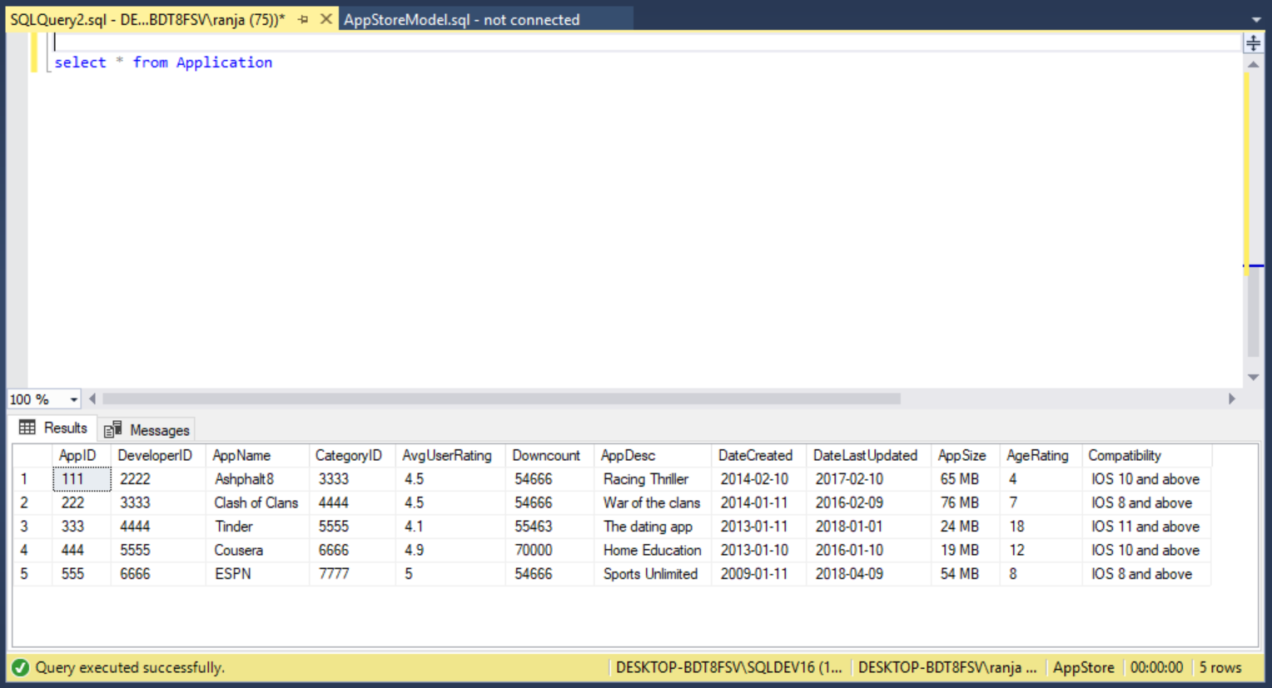

**Entity Category**

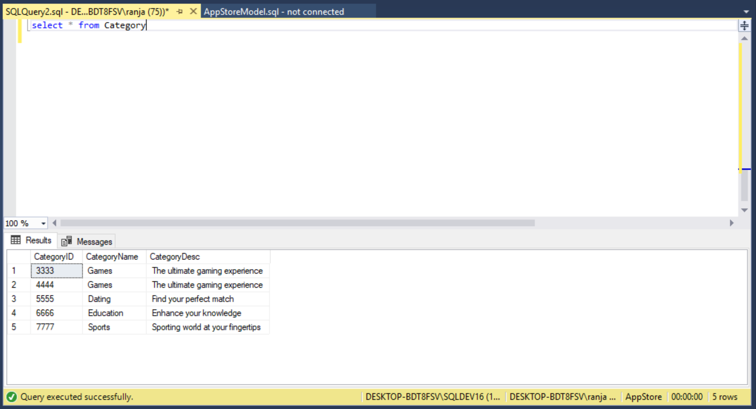

**Entity Developer**

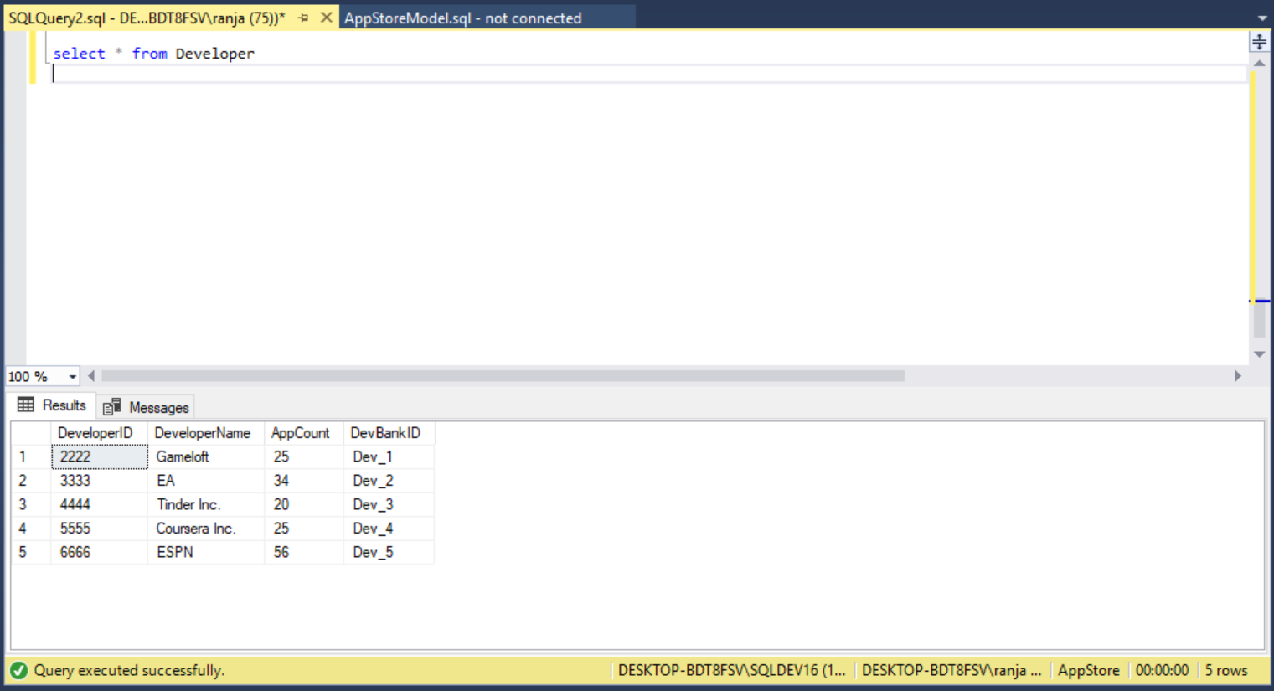

**Entity Ratings**

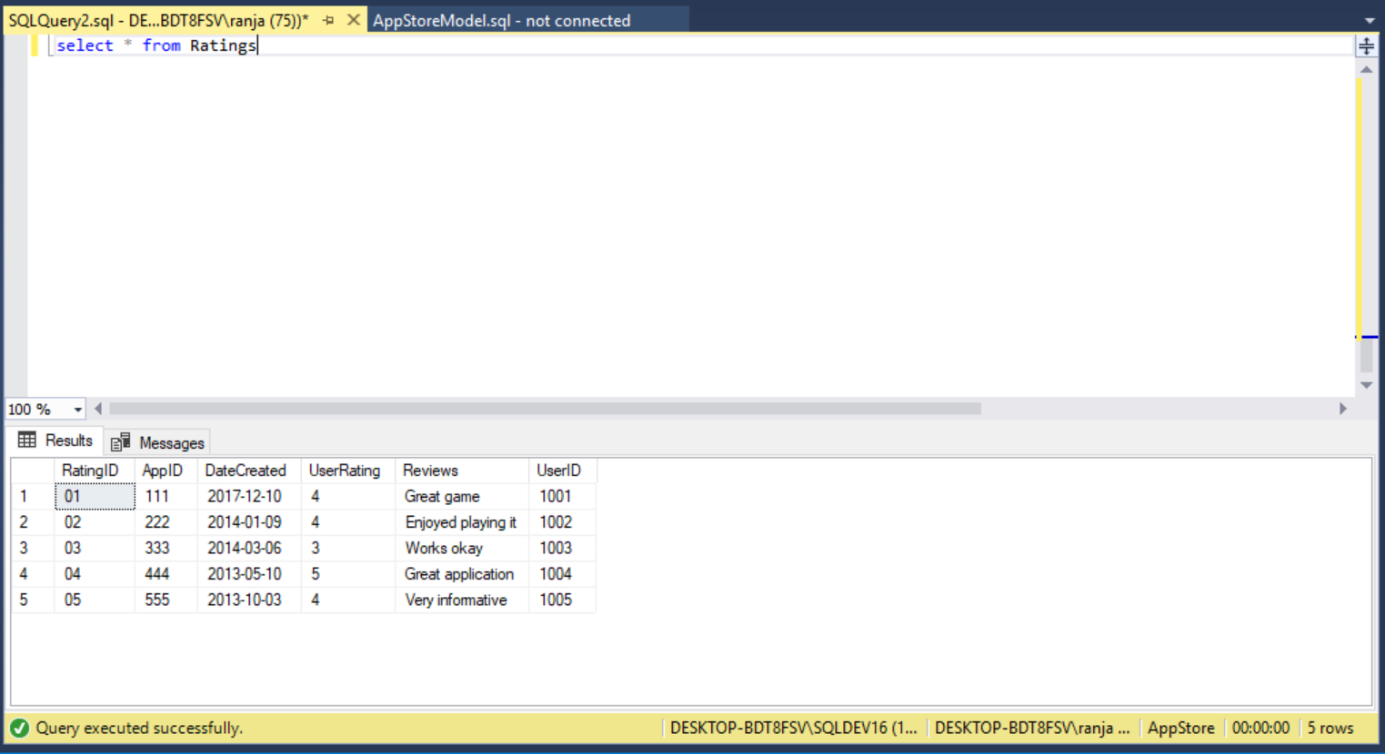

**Entity Users**

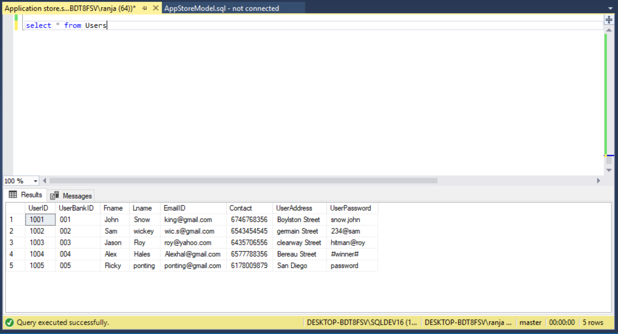

**Entity Invoices**

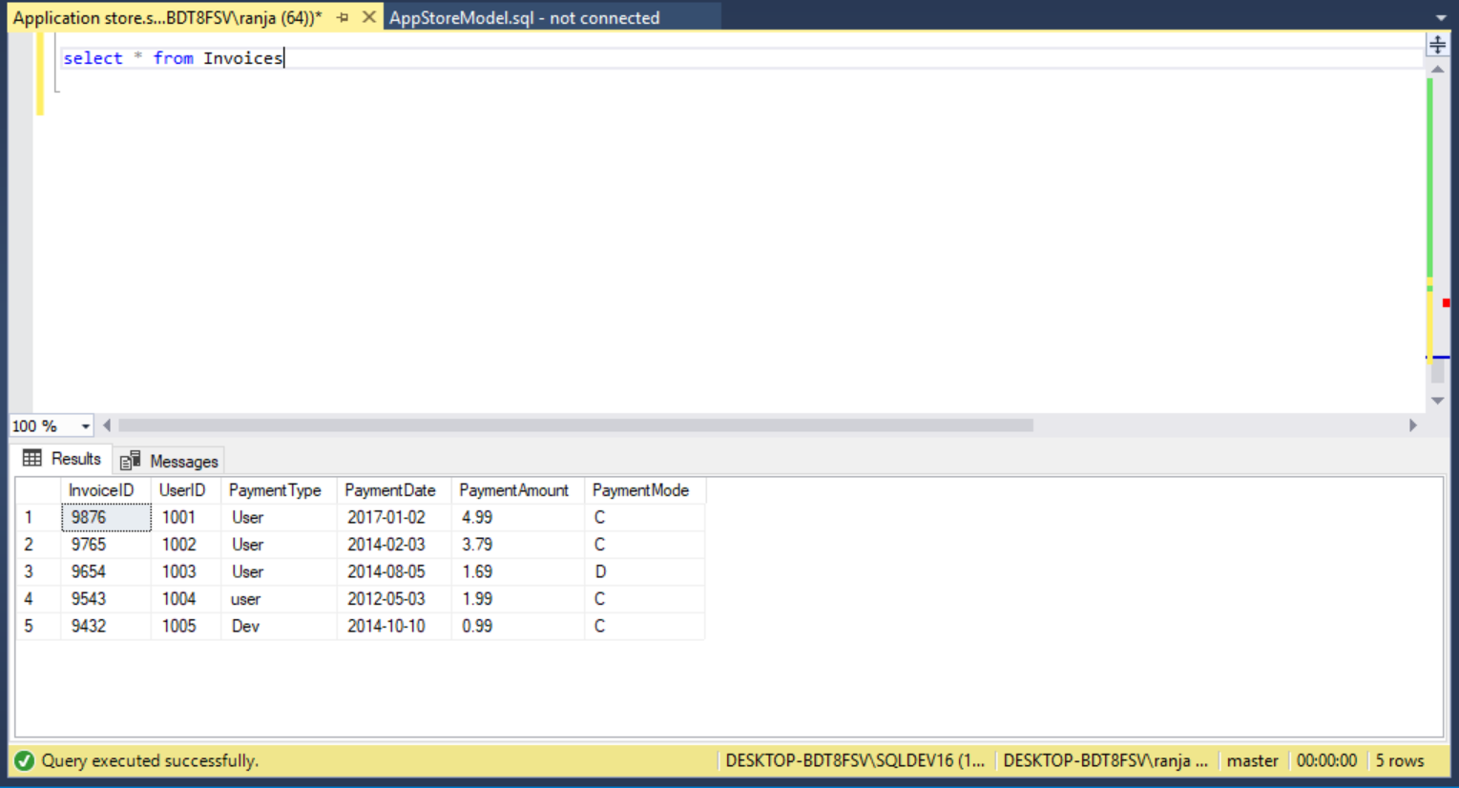

**Entity Downloads**

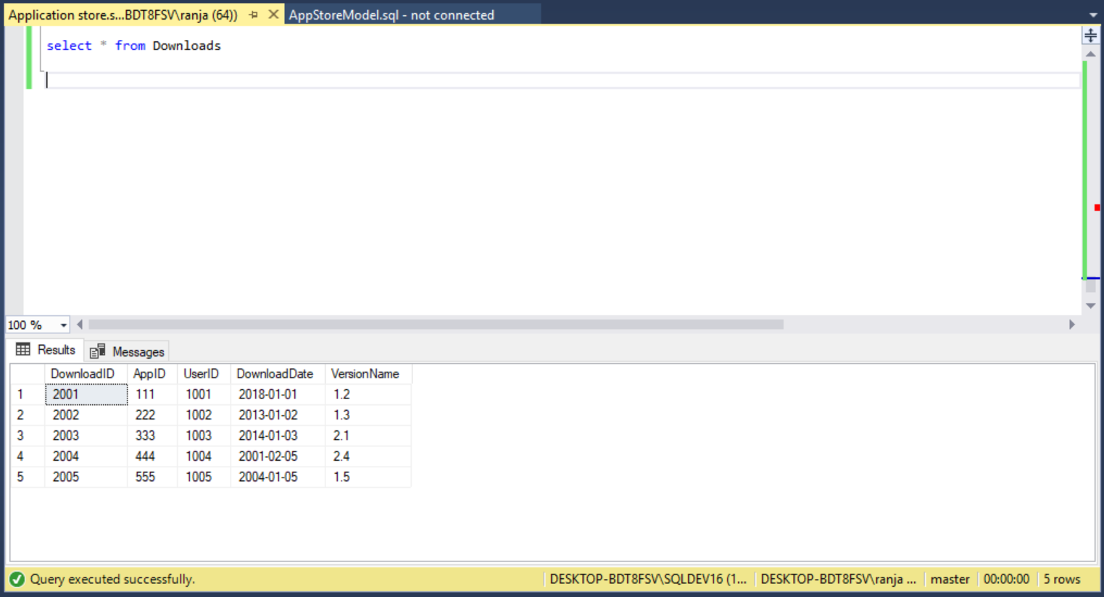

**Entity Version**

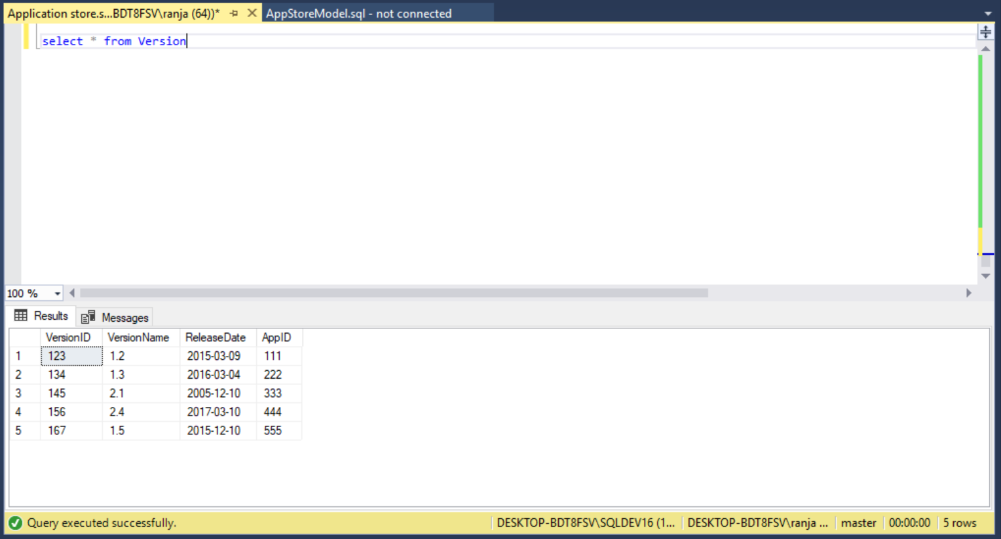

**Entity Devices**

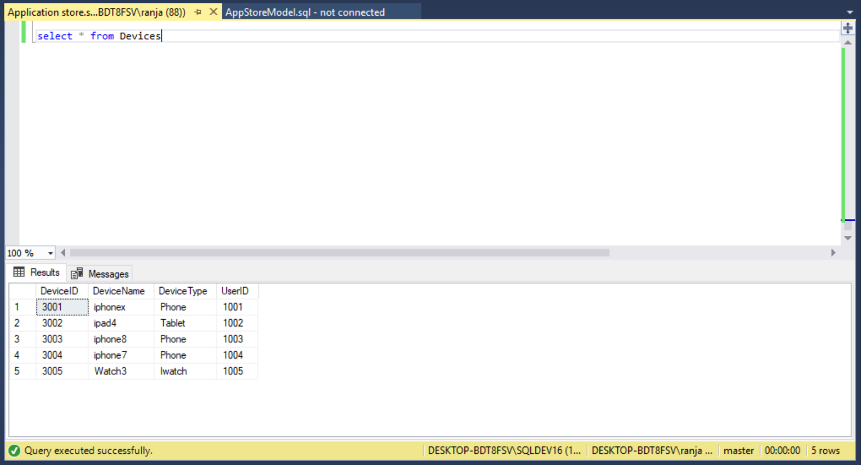

**Entity DevBankDetails**

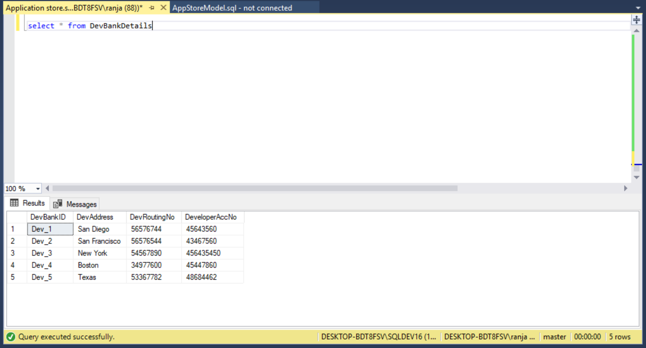

**Entity UserBankDetails**

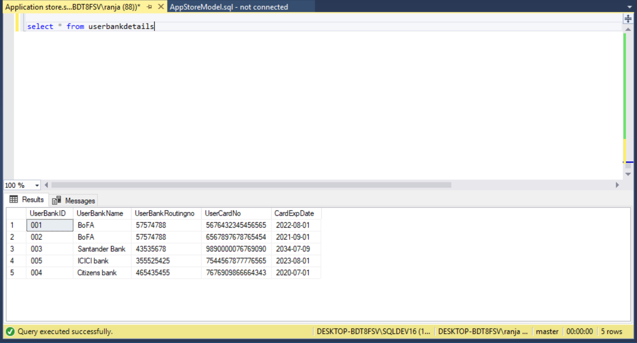

**Toad Model**

